AI Communication Assistant
Milestone 2
Google ADK sequential multi-agent workflow with Cartesia text-to-speech
System overview. The current implementation is a four-step sequential agent pipeline that accepts non-English user text, translates it into English, summarizes the translated content, and optionally converts the summary into speech. The workflow is implemented in Google ADK using a root SequentialAgent and is executed in Colab with InMemoryRunner.
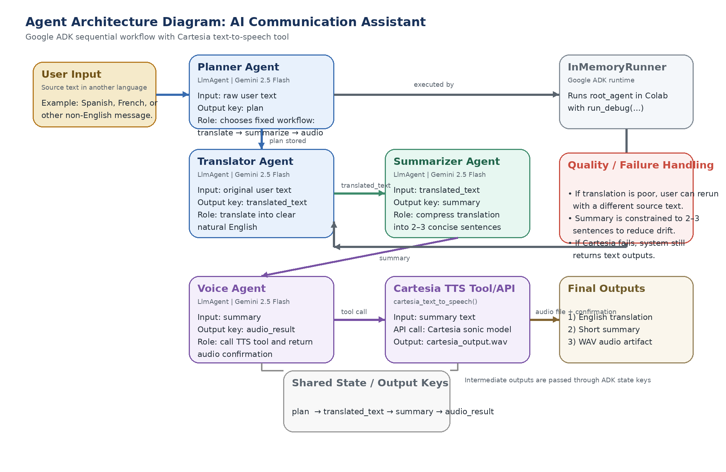

1. Agent Roles and I/O
The system uses four agents and one external tool/API. Each agent has a focused role and passes its output to the next stage through ADK state keys.
- Planner Agent. Input: raw user text. Output: plan. Chooses the workflow. In the current milestone version, the plan is fixed: translate the user text, summarize the result, and generate audio from the summary.
- Translator Agent. Input: raw user text. Output: translated_text. Uses Gemini 2.5 Flash to translate the original message into clear English while preserving meaning and tone.
- Summarizer Agent. Input: translated_text. Output: summary. Produces a short 2–3 sentence summary of the English translation so the user gets the key meaning quickly.
- Voice Agent. Input: summary. Output: audio_result. Calls the Cartesia text-to-speech tool to synthesize a spoken version of the summary and returns a confirmation or artifact reference.
- Cartesia TTS Tool/API. Input: summary text. Output: WAV audio file. External API tool that turns the final summary into spoken audio. This is the main tool integration in the milestone deliverable.

2. Communication and Dataflow
Communication between components is sequential and deterministic. The root SequentialAgent runs the Planner Agent first, then the Translator Agent, then the Summarizer Agent, and finally the Voice Agent.
ADK output keys act as the shared state for inter-agent communication. The Planner Agent writes plan, the Translator Agent writes translated_text, the Summarizer Agent writes summary, and the Voice Agent writes audio_result. Each downstream component reads the output of the previous step.
This design is intentionally simple for Milestone II. It reduces routing complexity, and clearly demonstrates agent decomposition, tool use, and dataflow.
Step | Component | Consumes | Produces
1 | Planner Agent | User text | plan
2 | Translator Agent | User text | translated_text
3 | Summarizer Agent | translated_text | summary
4 | Voice Agent + Cartesia Tool | summary | audio_result / WAV file

3. Failure Handling and Quality Control
The current milestone implementation handles quality mostly through constrained prompts and graceful fallback behavior. The translator is instructed to preserve meaning and tone, and the summarizer is constrained to output only a short 2–3 sentence summary. These prompt constraints reduce drifting, overlong responses, and formatting errors.
If translation quality is weak, the user can rerun the system with revised input or a shorter source passage. If summarization quality is weak, the summary stage can be rerun using the translated_text produced by the previous step. This makes the workflow easy to debug because each intermediate output is visible and separable.
If the Cartesia API fails or audio generation is unavailable, the system can still return the translated text and summary. In other words, speech output is additive rather than blocking. This keeps the core communication-assistance functionality usable even when the external tool is unavailable.
For a future version, quality control can be improved by adding automatic language detection, confidence checks, a retry branch for failed tool calls, and a user review step before speech generation.

4. Implementation Notes
The prototype is implemented in Google Colab and uses Google ADK with InMemoryRunner for testing. Gemini 2.5 Flash is used for the planner, translator, summarizer, and voice agent reasoning steps.
The architecture aligns with the original project proposal: the planner coordinates multiple specialized agents, and the system provides practical communication support by combining translation, summarization, and optional audio output.
This version is intentionally scoped down from the full proposal. OCR, document parsing, simplification, and email reply generation (if possible) are reserved for later milestone deliverables.

5. Google ADK UI Implantation

